Kol Simcha Torah Gazette
For parshas shemos 5786
Vol 10 Issue 14 (Whole #480) 21 Teveth 5786/ January 10, 2025
Printed L’illuy nishmas Nechama bas R’ Noach, a”h
For a free subscription, please forward your request to keren18@juno.com
Past emails can be found on the website ShabbosStories.com under Brooklyn Torah Gazette
Bondi Victim Revealed As Jewish Minutes Before His Murder; Final Act Was Donning Tefillin

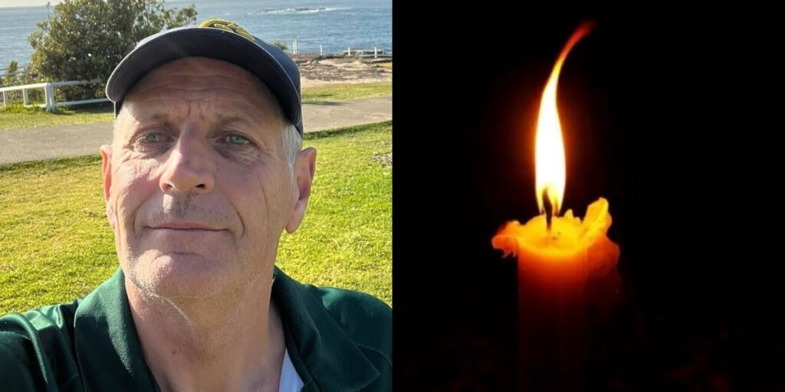Peter Meagher, H’yd

An extraordinary and deeply moving story was revealed about one of the Bondi massacre victims—the story of a “hidden Jew” who rediscovered his identity just minutes before being murdered.
Peter Meagher, H’yd—known to friends and family as “Marzo”—was a former New South Wales police detective and well-known community photographer, who until that moment had been widely regarded as non-Jewish.
However, according to a Collive report, Chabad bochur Shalom Druin and other bochurim at the fateful Chanukah event were offering passersby the opportunity to put on tefillin, together with Rabbi Eli Schlanger, H’yd. As they were preparing to leave for another Chanukah event, Shalom noticed a man holding a camera and asked him whether he was Jewish.

“But My Grandmother was [Jewish]”
“I’m not Jewish,” the man replied, “but my grandmother was.”
Shalom pressed gently: “Was she your mother’s mother or your father’s mother?”
“She was my mother’s mother,” the man answered.
Shalom replied, “If that’s the case, you’re Jewish—100% Jewish.” Shalom and other bochurim convinced Meagher, H’yd, to put on tefillin.

His Final Act of His Life
Ten minutes later, the terror attack began, and Meagher was murdered Al Kiddush Hashem. The final act of his life was the kiyum of a mitzvah—putting on tefillin.
But the story does not end there.
Bondi resident Chavi Israel, who survived the massacre, recounted a story about her friend Chana Michla Deitz, who was also present during the attack. She lay on the ground with her daughter, very close to Peter, H’yd, and witnessed his final moments.
Instinctively, without knowing that he was Jewish, Chana began to recite Shema Yisrael on his behalf. She later said she had felt an overwhelming, inexplicable need to do so. Shocked by his death, she then began davening fervently, pleading to Hashem that it wouldn’t be her or her daughter’s last day. B’Chasdei Hashem, they survived the massacre.

Reprinted from the Yeshiva World News Israel Desk - Jerusalem

How Jewish Parents Can
Protect Their Children From
Pharaoh’s “Evil Decree”
From the Teachings of the Lubavitcher Rebbe
Rabbi Menachem Mendel Schneerson, Zt”l
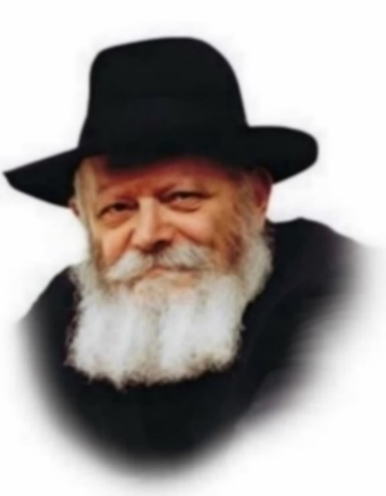
One of Pharaoh's harshest decrees against the Jews was his order to throw every newborn boy into the Nile, as related in this week's Torah portion, Shemot. The Passover Hagada, read each year at the seder, adds the following insight: " 'And our burden'-this recalls the drowning of the male children, as it is said, 'Every son that is born you shall cast into the river, but every daughter you shall keep alive.' "
Our Sages explain that the word "burden" is equated with the raising and educating of children, implying the preeminent responsibility resting on Jewish parents. Our Sages understood that great effort must be expended in order to rear Jewish children properly. Parents and teachers must share involvement in this holy task, investing much time and energy to ensure a younger generation that will continue the Jewish way of life.
And yet, together with the recognition that raising Jewish children is hard work, the Torah promises that the rewards we reap will be well worth the effort. In fact, the more self-sacrifice a parent has on behalf of his children's Jewish education, the more he is assured that his children will be strong in their Judaism and untouched by Pharaoh's evil decree, whether thousands of years ago or today. It was precisely those Jewish children born under the threat of extinction in Egypt who were the first to recognize G-d at the splitting of the Red Sea, declaring, "This is my G-d and I will extol Him."
Why should raising Jewish children require so much effort? Because our children are the foundation upon which the entire Jewish nation rests. This secret has long been known to our enemies. It was for this very reason that in communist Russia the authorities tried especially hard to suppress Torah learning in schools attended by the youngest of Jewish children. "They have plenty of time to learn Torah when they grow up," the communists claimed, knowing full well that the Jewish child's formative years spent in a Jewish atmosphere posed the greatest threat to the atheistic regime.
In the Talmud, Rabbi Yehoshua ben Gamla is remembered because of his educational innovation - the institution of publicly funded Torah classes for children, commencing at the age of five or six, in all locations where Jews dwelled. Thousands of years later his name is still revered because of this accomplishment.
Jewish parents must therefore do all in their power - physically, spiritually and monetarily - to ensure that their children are enrolled in schools where they will be instilled with our timeless Jewish values. For the education of our children is indeed our "burden"; at times, personal sacrifice may be required. In the merit of this, we will raise a generation of Jews who will again be the first to recognize G-d, in the complete and Final Redemption with the coming of Moshiach, speedily in our day.

Reprinted from the Parashat Shemos - December 27, 2002 - 22 Tevet, 5763 edition of L’Chaim, a publication of the Lubavitch Youth Organization. Adapted from Likutei Sichoth of the Lubavitcher Rebbe.

Rav Avigdor Miller on How to Believe in the Coming of
Melech HaMoshiach

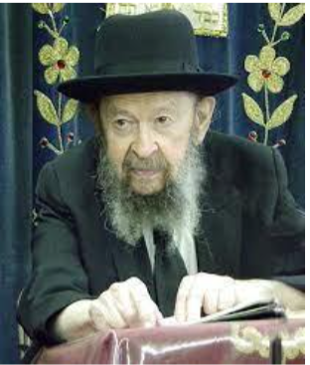

QUESTION: How could anybody really believe in the coming of a melech haMoshiach? If we don’t see him in front of us, so how could someone say he really believes in it?
ANSWER: And the answer is when a person trains himself to be an eved Hashem he comes to believe in the Word of Hashem. It’s absolutely possible! If Hakadosh Baruch Hu told us that there’s going to come a goel, and you’re a loyal eved Hashem, absolutely you could believe in it!
It’s only when people are stubborn and they prefer to listen to the foolishness of the outside streets. You walk in the streets, what are they talking about? Mets. Yanks. That’s all. A meshugeneh crazy world. They’re steeped in foolishness. But people yield to them. He wants to be part of the world and he yields.
No! I’m an eved Hashem. I disregard the umos haolam (nations of the world). They’re nothing. What they’re speaking about is nothing, it’s sheker. What Hakadosh Baruch Hu told me by means of His neviim (prophets), that’s emes (the truth). It’s more emes than this world is emes. What do you think? Broadway in Manhattan is going to last forever? Someday Broadway in Manhattan will be wiped out. It will happen someday. Even the forests might grow where Broadway is today.
So, it’s all foolishness, Olam Hazeh. Butּ„ – the words of Hashem,– will be forever; it will always be fulfilled (Yeshaya 40:8).
So, a person who is an eved Hashem, he can understand that, absolutely. To him, the coming of Moshiach is a reality, as true as anything else. It’s only a matter of gaining the proper Torah attitude. October 14, 1999

Reprinted from a recent email of Toras Avigdor. Adapted from a classic Thursday night hashkafah lecture delivered by Rav Miller on October 14, 1999.

Reprinted from a recent Toras Avigdor email.

Thoughts that Count
for Our Parsha

And behold, it was a weeping boy... and she said, "This is one of the Hebrews' children" (Ex. 2:6)
How could Pharaoh's daughter have recognized that the child was Jewish, just from his cry? This is because a Jewish cry is unique; even when he weeps, a Jew is filled with hope. (Rabbi Mordechai Chaim of Slonim)

And an angel of G-d appeared to him in a flame of fire from the midst of the thorn bush; and he looked, and behold, the thorn bush was burning with fire, but the thorn bush was not consumed (Ex. 3:2)
A person is likened to a tree of the field: the Torah Sage is a fruit-bearing tree and the simple Jew is like a tree that does not give fruit. Nonetheless, the "flame of fire" burns precisely in the "thorn bush" - in the simple Jew. A Jew who prays and recites Psalms with simple faith in G-d possesses a fire of holiness derived from purity of heart, even if he does not understand the words. Furthermore, the "thorn bush is not consumed"; the burning flame of the simple Jew can never be extinguished, as he is perpetually thirsty for Torah. (The Baal Shem Tov)

He returned to Egypt; and Moses took the staff of G-d in his hand (Ex. 4:20)
While Moses certainly showed Pharaoh the proper honor due a king, he nonetheless "took the staff of G-d in his hand" in all his dealings with him; he was prideful in his heritage, imbued with an attitude of G-dly assurance, and without any feelings of inferiority. (Likutei Sichot)

Moses returned to G-d and said, "L-rd! Why have You mistreated this people? Since I came to Pharaoh to speak in Your Name, he made things worse... You have not saved this people at all" (Ex. 5:22-23)
We mustn't resign ourselves to the present exile with the excuse that "such is the will of G-d." The Redemption is near, yet it is still bitter and painful. Therefore, even while reaffirming our absolute faith that "the ways of G-d are just," we are also to express our anguish with the prayerful outcry "How much longer?" and ask for the immediate coming of Moshiach. (The Lubavitcher Rebbe, 5743)

Reprinted from the Parashat Shemos - December 27, 2002 - 22 Tevet, 5763 edition of L’Chaim,

What is the Jewish View on Assisted Suicide?
By Yehuda Shurpin

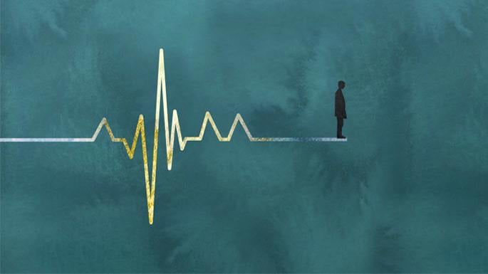
Art by Sefira Lightstone
As society’s attitudes change and conversations about end-of-life choices intensify, Jewish law brings a clear yet nuanced approach.
On the one hand, we recognize the terrible agony—both physical discomfort and emotional distress—that may drive a person to feel their time has come. At the same time, we are acutely aware that life is not ours, that every moment on earth has purpose, and that we do not always have the full picture.
As a rule, halachah firmly prohibits assisted suicide. Life is a divine trust of infinite value, something no person has the right to give up or take away. At the same time, there are very specific situations when we allow a person to die naturally without artificially prolonging their suffering.
Here is how Jewish law balances the sanctity of life and the dignity of end-of-life care.
The Supreme Value of Life
Judaism places the highest value on human life. The Talmud teaches that Adam was created alone—the only human in the entire universe—to convey a powerful message: destroying a single life is considered the destruction of an entire world, and saving one life is equivalent to saving an entire world.¹ Because of this, one may not kill another person, even to save one’s own life, regardless of the other person’s condition. That includes someone who is comatose, cognitively impaired, physically disabled or terminally ill.²
This commitment to preserving life is so important that nearly all commandments are set aside to save a life.³ We even violate Shabbat to preserve life.⁴ Commentaries add that someone who refuses to desecrate Shabbat to save their own life is considered culpable for their own death, for which they will be held accountable.⁵
And this applies even when life can be extended only briefly. Every moment of life has infinite value.⁶
Whose Life Is It?
The reason why Judaism is so firm on not taking life is that it is not personal property someone can forfeit at will. Rather, we are G-d’s trustees, responsible for guarding the life entrusted to us.⁷
We believe that every breath has purpose, beyond what we can fathom. As long as G-d has decided that we are here on earth, it is because we have a mission to accomplish. G-d is beyond our understanding, and we may not know what our mission is—but we can be sure that it’s there.
And once that mission is complete, G-d alone decides to bring our souls back to Him, at the time He deems right.
That is why the prohibitions against murder and suicide share the same foundation: no one, neither another person nor the individual himself, may destroy a divinely granted life.⁸
This applies even to what we may deem a life of “poor quality.”
Life is not a means to an end; it is intrinsically sacred, whose worth is not based on productivity, comfort, or an expected outcome. There is no objective measurement by which the value of a human life can be calculated.⁹
This principle is rooted in the Torah’s teaching that man is created in the image of G-d.¹⁰ Just as it is impossible to fathom or quantify G-d, neither can we begin to appreciate the full objective value of any human life.
It follows that assisted suicide is akin to murder. So, neither doctors nor anyone else is to do anything at all that will hasten a person’s demise.
At the same time, we recognize that not every life-prolonging treatment is appropriate. To understand this, let’s first step back and examine the role of doctors in Jewish tradition.
What Role Do Doctors Play?
Today, there are some who argue that the physician–patient relationship grants doctors special authority to take steps that would otherwise be illegal. In Judaism, however, the role of a doctor is to diagnose and heal—not to nay-say or to do the opposite of healing.
The Torah’s mandate for doctors is seen in the verse “v’rapo yerape”—“heal, he shall heal.”¹¹ This double expression is understood by the Sages as a mandate to heal.¹²
Accordingly, any active involvement in helping another individual end their life falls outside the Torah’s mandate of healing and is outside of the doctor’s purview.
There are also many times when doctors provide an unrealistic, gloomy prognosis, presenting ending life as the only humane option. Experience has shown that many people have outlived these predictions and celebrated many happy milestones long after the medical establishment predicted their demise. So don’t lose hope!
Suffering and Compassion
At the same time, alleviating pain and distress—even of animals—is itself a mitzvah.
A foundational precedent appears in the Talmud’s account of the final moments of Rabbi Judah the Prince. As he lay dying in great agony, his maidservant distracted those who were praying for him to live, and he died shortly thereafter.¹³ Importantly, she did not perform any act that caused his death; she merely removed an impediment that was artificially prolonging the dying process.
From this episode, halachah draws a distinction between actively hastening death, which is always forbidden, and removing an obstacle that merely delays an otherwise imminent natural death, which may be permitted only in specific and narrowly defined circumstances.
The Rama, in the Code of Jewish Law, articulates this distinction: “If there is something that delays the soul’s departure … one may remove it. But one may not do anything that hastens death.”¹⁴

Practical Implications—With Extreme Caution
This framework guides contemporary halachic rulings, but its application is complex and highly case-specific.¹⁵
Pain management, including the use of strong narcotics or palliative sedation, is permitted even if it may indirectly and inadvertently shorten life, provided the sole intent is to relieve suffering and not to hasten death. Even here, careful medical judgment and halachic guidance are required.
Life support and ventilators may not be actively shut off to cause death. In limited cases involving a terminal patient, it may be permissible not to initiate extraordinary or non-curative interventions that only prolong the dying process—but this determination depends on many variables and cannot be made in the abstract.
Qualified rabbis who are consulted on these matters are steeped in halachah and trained to determine exactly when to apply the Torah’s requirement to save life at all costs and when to recognize that we’ve done our part.
Nutrition and hydration, including feeding tubes, are generally viewed as basic care rather than extraordinary treatment and therefore may not be withdrawn in most situations.
Standard DNR orders are often too broad, instructing that life be ended more liberally than acceptable by Jewish standards, and should not be signed without careful consultation with a rabbi.
The Infinite Value of Even Brief Life
Watching a loved one suffer is agonizing. It sometimes appears as if there is no joy on the horizon. And it is precisely then that we place our faith in G-d and trust that He has a plan, our lives have infinite purpose, and that all is truly for the best.
Families and individuals facing issues related to end of life are encouraged to reach out to their family rabbi and/or the Chayim Aruchim organization.

Footnotes
1. Mishnah Sanhedrin 4:5 (Jerusalem Talmud Sanhedrin 4:1).
2. See Mishneh Torah, Hichot Rotze’ach Ushemirat Hanefesh, 2:7; Sefer Chassidim 186; Teshuvah M’Ahavah 1:53.
3. The only exceptions are the laws against murder, idolatry and certain acts of sexual misconduct. See Shulchan Aruch, Yoreh De’ah 157:1, 195:3.
4. Talmud, Yoma 85a. 5. See commentary of Rabbenu Nissim (on Rif) ad loc;
6. Talmud, Yoma 85a. 7. Mishneh Torah, Laws of Wounding and Damaging 5: 1; Shulchan Aruch, Choshen Mishpat 420:31; Shulchan Aruch Harav, Choshen Mishpat, Laws of Bodily Damages 4.
8. See, for example, Radbaz on Mishneh Torah, Hilchot Sanhedrin 18:6.
9. See, for example, Minchat Shlomo 1, 91:24.
10. Genesis 1:27. 11. Exodus 21:19. 12. Talmud, Bava Kama 85a.
13. Talmud, Ketubot 104a. 14. Rama, Shulchan Aruch, Yoreh De’ah 339:1.
15. For a general overview on this, see Nishmat Avraham on Yoreh De’ah 399:1.

Reprinted from the current website of Chabad.Org.

Yeshiva Bochur Tried To
Register For Marriage and Discovered He’s Not Jewish

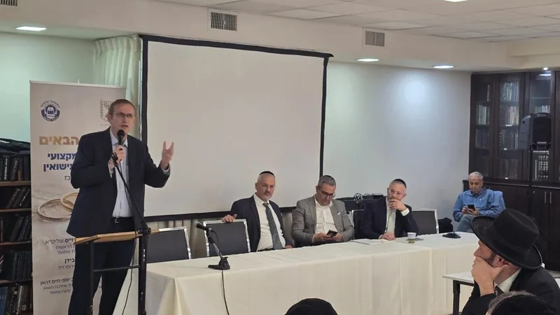The conference. Photo: The Ministry of Religious Services

Israel’s Ministry of Religious Services held a professional conference last week for marriage registrars from across the country at the Givat Shmuel Religious Council.
At the conference, an extraordinary case was presented to the participants, illustrating the heavy responsibility borne by the marriage registrars.
A couple arrived to register for marriage according to halacha at one of the religious councils in Israel. The chasan—who had grown up with an adoptive family since infancy—is a talmid yeshivah who arrived at the registry fully confident in his halachic status.
However, during the routine lineage verification, the marriage registrar discovered a detail that changed the entire picture. He noticed what appeared to be a minor but suspicious technical detail: the name of one of the parents was missing from the records.
The registrar launched a deeper inquiry, which led to a surprising discovery: the chasan has a biological brother who was adopted in childhood by a different family. Further examination revealed that this brother had married shortly beforehand, and in his case the marriage registration process was preceded by a proper giyur, after it emerged that the original adoption had not included a full giyur.
The conclusion was unavoidable: to the shock of the chasan and his relatives, it was determined that he is not Jewish according to halacha. The painful discovery prevented thorny halachic issues and underscores the critical importance of the verification procedures carried out in marriage registration offices.
A source familiar with the details said that since the chasan was Shomer Torah u’mitzvos, the giyur process was quick and straightforward, and the couple’s chasunah took place at the scheduled time.
The head of the Marriage Department at the Ministry, Rabbi Chizkiyahu Samin, referred to the case at the conference, saying, “The story revealed here is a chilling reminder of the importance of your avodat hakodesh. We must continue to combine advanced, welcoming service with uncompromising adherence to halacha and to the identity of the Jewish people.”

Reprinted from the Yeshiva World News website.

“I Couldn’t Watch Innocents Die”: Bondi Beach Chanukah Massacre Hero Recounts Terror Attack

A Muslim vendor who intervened during a deadly antisemitic attack at Bondi Beach has described the moment he ran toward one of the assailants and wrestled a gun from him in an effort to protect civilians.
Ahmed al Ahmed said in an interview with CBS News that his sole intention was to stop the gunman from killing innocent people.
“My target was just to take the gun from him, and to stop him from killing a human being’s life and not killing innocent people,” he said. “I know I saved lots, but I feel sorry for the lost.”

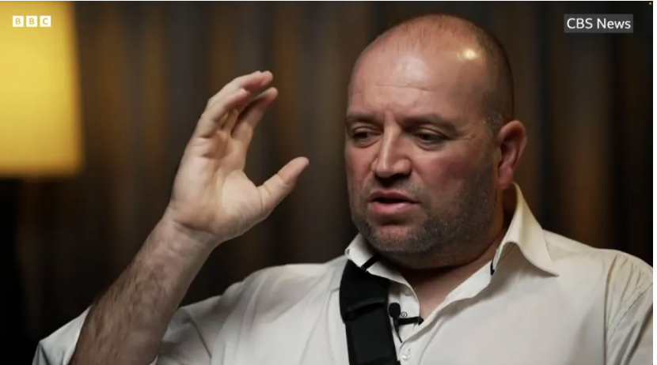
Ahmed al Ahmed, the hero of Bondi Beach.

The attack took place on the first day of Chanukah during a Chabad event on Sydney’s Bondi Beach, when father and son Sajid and Naveed Akram opened fire, killing 15 people and wounding dozens. Authorities later declared the shooting an antisemitic terrorist attack.
Al Ahmed, who works as a vendor in the area, was captured on video ducking between parked cars as gunfire erupted before charging one of the attackers and grappling with him to seize his weapon. During the struggle, al Ahmed was shot multiple times in the shoulder and later underwent several rounds of surgery.
Recalling the confrontation, al Ahmed said he jumped on the gunman’s back and held him while ordering him to stop. “Drop your gun, stop doing what you’re doing,” he recalled saying.
He told CBS he acted because he could not bear to see people being killed or hear the sound of gunfire as bystanders screamed for help.
Al Ahmed said he had been at the beach to get a cup of coffee when the shooting began.
Originally from Syria, al Ahmed emigrated to Australia in 2007. Speaking to Agence France-Presse days after the attack in al Ahmed’s hometown of Al-Nayrab, his uncle Mohammed described the intervention as a point of pride for the family. “His act is a source of pride for us and for Syria,” he said.
Australian media reported that the government has fast-tracked and granted visas for several members of al Ahmed’s family following the attack. In a statement, Home Affairs Minister Tony Burke praised al Ahmed’s actions, saying, “Ahmed has shown the courage and values we want in Australia.”

Reprinted from the December 29, 2025 website of Yeshiva World News.

New York Governor Steps In To Prevent
Demolition of Century-Old Brooklyn Shul

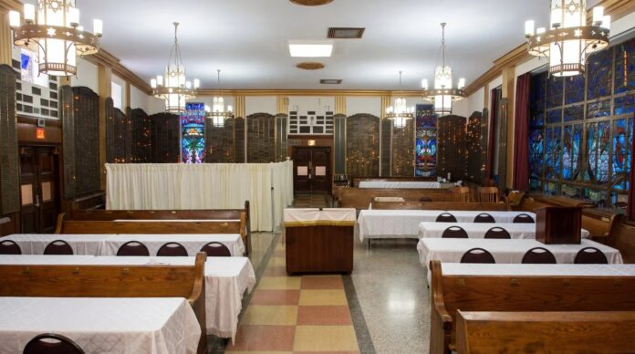

New York Gov. Kathy Hochul, a Democrat, has halted the planned demolition of the historic Kingsbrook Shul, formerly Congregation Chaim Albert, in the East Flatbush neighborhood of Brooklyn, N.Y.
Built in 1950 on the grounds of the former Kingsbrook Jewish Medical Center, the shul was to be razed as part of a redevelopment of the larger site into affordable housing. The project, which is partly financed via the state’s housing and community renewal program, would include hundreds of residential units.
The governor’s decision came amid a lawsuit in the state’s supreme court in Kings County, in which Congregation Chaim Albert sued One Brooklyn Health System, the entity that owns the property.
In the June 13 complaint, the congregation alleged that the shul as always intended to remain a permanent house of worship and should not be treated as a disposable real estate asset.
According to the complaint, shul services were suspended during the COVID-19 pandemic but were never allowed to resume, even after public-health restrictions ended. The congregation alleged that the prolonged closure was used to justify removing the Kingsbrook Shul as part of the redevelopment.
Hochul said she “led the effort to save the historic Kingsbrook Shul from its demolition” in a statement in which she encouraged “leadership from the hospital and synagogue to find a path forward where both sites can prosper and serve the community.”
Aron Wieder, a state assemblyman, said that “protecting institutions with deep community and cultural significance is important.”
Letitia James, the state attorney general, also said that “this synagogue has been meaningful to the community for decades, and I am grateful a treasured piece of Jewish history in New York will be preserved.”

Reprinted from the JNS.

The Lesson of Double Spigots on the Barrel of Wine

“There once was a man who had a barrel full of wine. He used to pour the wine from it through a spigot at the bottom of the barrel, and this took ten minutes. Someone told the owner of the barrel, ‘Make another tap in the barrel, and the wine will pour through both of them in five minutes!’
The owner of the barrel replied, ‘I would listen to your wise advice, if I could extract more wine from the barrel than the amount of wine that is in it. Since I can’t do that, why do I need a second tap? Boruch Hashem, I have enough time to wait five more minutes...”

Reprinted from the Parshas Vayechi 5786 email of The Way of Emunah: Collected Thoughts on the Weekly Parshah from Rabbi Meir Isamar.

